FINAL EXAM

The final exam must include this cover sheet with the student's name and the date as well
as the following statement:

Honor Pledge

This exam is my own work. I received no assistance from any other individual, commercial entity, or unauthorized source.

Suspected violations of the academic integrity policy of the University of Maryland
University College will be processed in accordance to the Procedures for Handling
Charges of Alleged Academic Dishonesty outlined in Policy 150.25 - Academic
Dishonesty and Plagiarism (http://www.umuc.edu/policy/aa15025.shtml).

In typing my name following the word 'Signature', I intend that this certification will have
the same authority and authenticity as a document executed with my hand-written signature.

Signature: [Insert your name here]

Date: [Insert date here]

CJMS 630 FINAL EXAM – CJ Security Management

Instructions:

1. Each question is worth 20 points and 25% of the final grade.

2. Each answer should run a total of 1-2 pages, single - spaced with one-inch margins. State your assumptions. Please do not repeat the question as a part of your answer; it’s not necessary.

3. Draw your answers from course readings, session notes (lectures), discussions, exercises and your personal insight. Students can use the textbook, an assessment tool, and outside resources; however, students cannot receive personal assistance from anyone.
This exam may be scanned using Turnitin.com.

4. Post your answers in the Assignment Folder on or before _ 12:00 mn (EST) 08/10/14. Do not submit DOCX or WPS files – turn in only DOC files.

Question 1.

What elements would you include in providing a layered security system for a three-building corporate campus that includes a five-story building housing, which is the headquarters office for a major pharmaceutical company in the following scenario? (HINT - start by identifying what you believe are the critical assets and their locations and work from there . . .) (Assume that there have been “Moderate” threat’s made against this company – however not too specific- employees are worried, and executives somewhat cautious in their daily activities.) There have been major protests in and around the facility, however only a few arrests have been made.

The campus is located adjacent to a river that flows into Chesapeake Bay and sits on ground 8 feet above sea level. The building is in a suburban location, sited on approximately five acres adjacent to an interstate highway ramp. Parking is included within the campus boundary and approximately 750 employees are present daily, plus approximately 50 visitors. The loading docks can be accessed from the parking lot via side roads.

Building 1 contains the headquarters offices and is where all of the company’s executives
work; all field administrative operations (human resources ect.) are coordinated from this
building. Building 2 is where sensitive research is conducted (scientist, and research) and computer – information technology is coordinated. Building 3 has what may be considered as the overflow operations for the company; sensitive training (laboratories), conference rooms and storage. The computer room is in the basement of Building 2 essentially to provide a cool operating environment. The storage facilities hold equipment and supplies used to maintain the grounds.

See the map below for the company. Light poles are indicated by the “+” symbol.

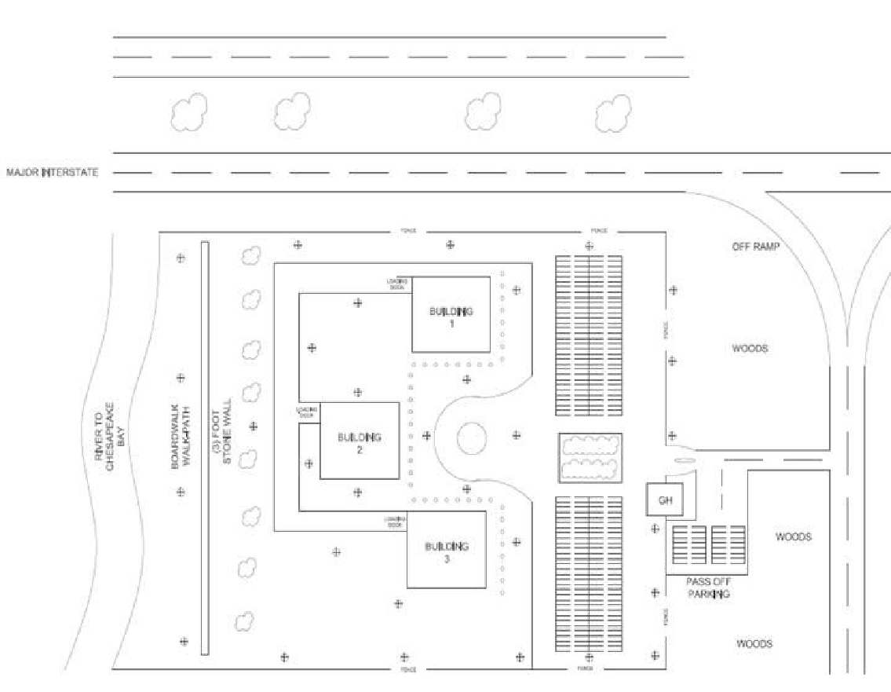

Question 2.

Your security firm is hired to provide recommendations for crime prevention for a renovated three four story 50-year-old brick apartment buildings located in Detroit, Michigan. Each building has twenty apartments priced in the upper-middle class range. There is a fairly large overflow parking lot exposed to the city streets. Each apartment is afforded one parking slot in a garage under the building. This apartment complex is part of a project to renovate the near downtown area and it is placed in an area where there is significant amount of crime about a quarter mile away. The adjacent streets have old businesses, some empty buildings, liquor store, a couple of bars and a popular corner café.

There will be a green landscaped buffer area that extends fifty yards all around the apartment complex to a new sidewalk; an exact landscape plan has not been furnished until you provide your ideas. However, there are several large old oak trees and mature purple and white flowered lilac shrubbery that has been preserved on the campus kept from a portion of an old inner city park. In your security plan what would you recommend in terms of crime prevention and target hardening security measures for this new residence complex? Explain the security measures recommended in terms of critical assets considering likely threats, vulnerabilities, risks and crime theories. Consider also what must be done prior to any recommendations being made. Note your opinions, and what options may be available for the client to consider. What are your
recommendations – list all, and think about conducting, and conducting a security/risk assessment – based on what is presented here.

Question 3.

As a security consultant you are asked to review a recent armed robbery and rape case
that happened on State University, USA, associated with the athletic complex. The crime
happened at night when Doris Franklin finished her late work out for the gymnastic team. She showered and dressed and ready to leave she noticed the last evening bus left at 10 PM. She just missed it. The janitor told her she would have to leave the building because he had to lock up the complex. She told him the bus had left and she did not want to walk back to the dorm in the dark and asked if she could call the campus police? He agreed and even stayed with her while she made a call to the campus police. She called the campus police and asked for an escort. The campus police said they could have a campus security officer come by in about 20 minutes if she could wait. She agreed. She told the janitor and he had her leave the building and wait immediately in front. After 30 minutes Doris got tired of waiting so she started to walk back in the direction of the dorm when a car approached her, two males brandished a weapon, at gunpoint forced her into the car, stole her purse and she was later raped twice at another location. Fortunately, she was not killed, during the incident and was left severely hurt on the roadside.

The security officer showed up 35 minutes after the call and could not find her. He had stopped for a coffee at McDonald’s before coming. He left the athletic building never calling in the fact she had not been escorted. The procedure is that security must always report the outcome of escort service in terms of person, time of pick up, when the person was safely delivered to their dorm and mileage.

The campus police and security said they are not responsible since Doris chose to leave and not wait for the escort. The security officer was somewhat delayed arriving, however, he picked up his coffee at a drive-through window and had already missed his break since they were short a security officer.

What are the premise liability issues in this case? As a security consultant, what are your findings?

Question 4:

You are a newly appointed administrator of a large public school district that has been experiencing high crime rates among the student population, both on and around campus
buildings and facilities. Thefts of property, vandalism and assaults are reported on a daily basis. The local PTA is upset that the school district has not addressed these problems adequately in the past, and now it appears that these longstanding problems are out of control. Recently, two students were shot in the hallway of the local high school during an altercation between two rival groups of gang members. Some students have reported observing drug transactions occurring in the bathrooms and in the parking lots, before, during, and after school hours.

Your job is to develop a short-term and long-term strategy to effectively deal with these problems. As with most public agencies, your school system is operating on a very limited budget, so you must choose your interventions wisely. Assume that there are no programs in place to effectively deal with these problems, but the PTA wants answers now! According to the evidence, which programs work, and which programs do not appear to work? Which ones would you consider using?

Consider the pros and cons of whatever program/procedure you suggest or implement. (Good luck!)

Question 5:

You are the appointed leader/supervisor of a group representing the office of a newly appointed Chief of Police for a large city experiencing high crime rates, which have been directly associated with gun violence on the street. (All of you are considered by the public as being police executives, and are equally responsible for the powers of the Chief of Police.) Street-level violence within the community has existed for years but the numbers of reported robberies, burglaries, murders, assaults, and theft have become increasingly prevalent in more recent times. The mayor’s office and various members of the community are demanding “answers” because you were hired to help reduce these types of crimes based on your expertise in the policy-making process. In order to make a difference in overall crime rates, you must address all serious issues relating to crime and its prevention. You have to address the crime problems mentioned above, but what does the research tell you?

Your job is to develop a short-term and long-term strategy to effectively deal with these problems. As with most localities, the various agencies working within your jurisdiction are operating under tight budgets, so you must choose your interventions wisely. Assume there are no programs in place to deal with the challenges that you are now facing. (You may want to consider what security tools you should, or may what to use in your evaluation.)

THE END – GREAT JOB!

